VySkan
Product Name | OBD-CAN 4G Smart Telematics Plug
Product Model | VO-CAN
Zero Installation. Deep Telemetry. Ultimate Stealth.
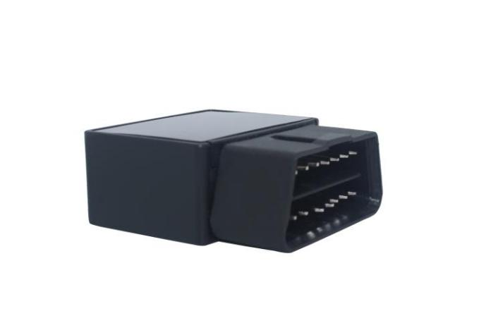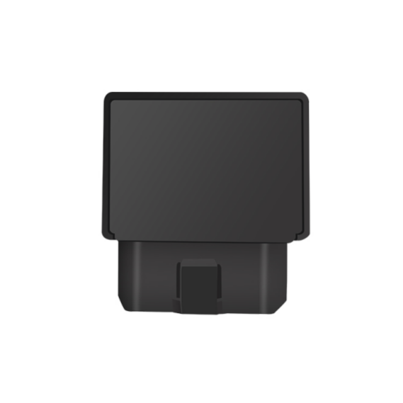
Engineered for auto finance, car dealerships, and usage-based insurance (UBI), this incredibly compact VO-CAN tracker eliminates installation costs completely. It seamlessly blends triple-mode GNSS tracking with deep CAN bus data extraction, pulling critical metrics like VIN, fuel levels, and engine temperature directly from the vehicle's onboard computer in seconds.

Core Value Propositions
- Zero-Cost Plug & Play Deployment
Simply plug it into the vehicle's standard OBD II port. No wiring, no mechanic required, and zero vehicle downtime, making it perfect for rapid mass deployment in rental fleets and dealership inventory.
- Deep CAN Bus Telemetry
Goes far beyond GPS dots on a map. Built-in support for KWP2000, ISO9141, and standard CANBUS protocols allows your platform to read raw diagnostic data (VIN, engine temp, fuel) directly from the ECU.
- Ultra-Low Power & Smart Sleep
Features an integrated 3D 3-axis accelerometer that detects vehicle motion. It automatically enters a deep sleep mode (drawing a mere 2.5mA) when stationary, strictly protecting the vehicle's battery during long-term inventory parking.
- Ultra-Compact Stealth Design
Measuring only 48mm × 25mm × 23mm, it is the smallest full-featured OBD tracker in its class. Its unobtrusive footprint ensures it won't interfere with the driver's legroom or draw unwanted attention.

Target Applications
- Car Rental & Dealerships (Rapid deployment & inventory management)
- Auto Finance & UBI Insurance (Mileage tracking & driving behavior)
- Corporate Fleet Management (Plug-and-play vehicle monitoring)
- Light Commercial Vehicles (Diagnostic tracking without wiring)
- Technical Specifications
3.1 Cellular & GNSS
Category | Specification | Description
Network Bands | 4G FDD-LTE: B1/B3/B5/B8  4G TDD-LTE: B34/B39/B40/B41GSM: 850/900/1800/1900MHz  (Optional) | Comprehensive 4G network coverage with reliable 2G fallback.
SIM Card | Micro SIM | Secure internal slot.
GNSS Module | GPS / BDS / GLONASS + LBS | Triple-satellite tracking plus LBS base station backup for underground garages.
Sensitivity | -162 dBm | Maintains strong signal lock in dense urban areas.
Start Time | Cold: Avg 32sHot: Avg 1s | Rapid satellite acquisition.
Antenna | Built-in FPC Antenna | High-performance integrated design.
3.2 Power & Electrical
Category | Specification | Description
Operating Voltage | DC 9V - 35V | Compatible with standard 12V passenger cars and 24V light trucks.
Working Current | Avg 35mA (ACC ON) | Standard active tracking mode.
Sleep Current | 2.5mA (ACC OFF) | Industry-leading ultra-low power consumption.
3.3 Interfaces & Diagnostic Protocols
Category | Specification | Description
Interface Type | Standard OBD II | Direct plug-in port.
K-Line Protocols | KWP2000 (5BPS / FAST)ISO9141 | Broad compatibility with legacy vehicle diagnostic systems.
CAN Protocols | CANBUS 11B/29B @ 250K/500K | High-speed data reading for modern ECU telematics.
Smart Alarms | Over-speed, Low-voltage, Offline | Built-in alerts for fleet safety and device tampering.
Data Storage | 800 Records (Blind-spot) | Automatically caches data during cellular drops and uploads upon reconnection.
3.4 Physical & Environmental
Category | Specification | Description
Dimensions | 48mm × 25mm × 23mm | The smallest footprint in its performance class.
Weight | 38g | Ultra-lightweight design.
Housing Material | ABS Plastic | Heat-resistant and durable.
Operating Temp. | -25℃ to 75℃ | Reliable operation in severe environments.
Operating Humidity | 5% - 95% RH | Resilient to in-cabin moisture.

Built for Rapid Integration & Telemetry
We know hardware is only half the solution. This OBD tracker is designed to drastically reduce your Time-to-Market (TTM).
- Supported Platforms: Seamlessly integrates with industry-leading tracking software including Wialon, Traccar, and enterprise custom dashboards.
- CAN Bus Ready: Comprehensive API documentation helps your IT team effortlessly parse not just GPS coordinates, but deep OBD telemetry data (VIN, engine status), achieving live dashboard connectivity in under 48 hours.
- A personalized service prepared for you
- 1× VO-CAN Sample Device (Pre-configured)
- Full API & Protocol Documentation
- 1-on-1 Technical Support from our Field Engineers
- Contact us
Website：https://vyskan.com/
Email: marketing@vyskan.com

